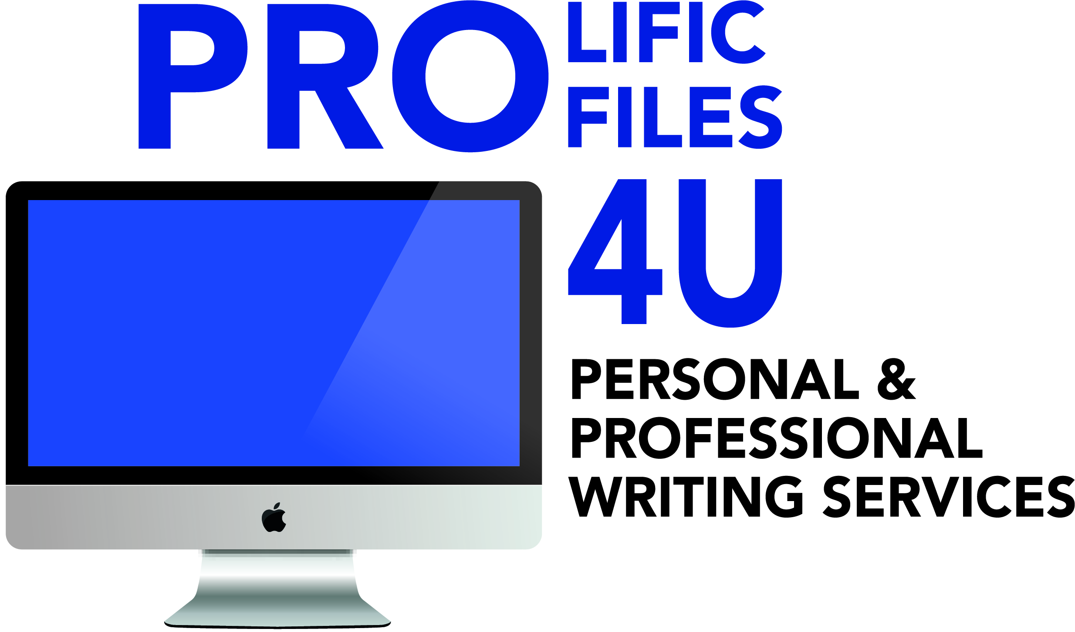
WRITING PACKAGES

WEB PAGER PACKAGE
2 Page Website Content and Professional Bio Blurb $275
3-6 Pages Website Content and Professional Bio Blurb $100 p.p.
7+ pages Website Content and Professional Bio Blurb $75 p.p.

DIGITAL MARKETING PACKAGE
Small Monthly Blog (1 Year)
Linked In and Facebook Profile (New or Revision)
One Email Marketing Campaign (New Blast Content or Revision)

$600
Same Package but with Weekly Blog (1 Year)
$1000
ANNUAL BLOGGING PACKAGE
1 Monthly Medium Article or 4 Small Weekly Articles: $500-- *Add Facebook Posting: $550
1 Large Monthly Blog: $600--*Add Facebook Posting: $650

EMAIL MARKETING PACKAGE
$ 130 for 2 Monthly Blasts
$100 for 1 Monthly Blast

ESSAY WRITING TUTORIAL PACKAGE
1 Month of Writing Lessons or PSAT/SAT Writing Prep.
College Entrance Essay Consultation (Includes initial outline
And 2 edits)
$225

ENTREPRENEURIAL START UP PACKAGE
Facebook Business Profile
Linked In Profile
2 Pages of Website Content
Professional Bio
$300

JOB SEEKER PACKAGES ( INCLUDES COVER LETTER, RESUME, AND LINKED IN PROFESSIONAL BIO, NEW OR REVISION)
Executive Level Package: ( Senior Mgmt.): $500

Mid-Mgmt. Level Package: $350

Career Changer’s Package: $350

Mid-Career Level Package: $300 (10+ years experience)

Professional Level Package: $250 (3-10 years experience)

Entry Level Package: $150 (Up to 3 years experience)

